Statement of purpose
Project-Based Submission
Project Title: Smart plant watering system with Audio Alert
Applicant: Pelluru Rambabu
Introduction:
I am an enthusiastic Electronics and Communication Engineering student with a strong interest in embedded systems and automation technologies. From my early academic years, I have been curious about how electronic systems can solve real-world problems. While observing household gardening and agricultural practices, I noticed that many plants either receive excess water or insufficient water due to lack of proper monitoring. This improper watering leads to poor plant growth and wastage of water.
Water is one of the most valuable natural resources, and efficient usage is very important. This inspired me to design and develop a Smart Plant Watering System with an Audio Alert feature. The aim of this project is to automate the irrigation process using sensors and a microcontroller so that plants receive the right amount of water at the right time.
This system monitors soil moisture levels continuously. When the soil becomes dry, the water pump automatically turns ON and supplies water to the plant. Once the required moisture level is reached, the pump turns OFF automatically. Additionally, an audio system provides voice or sound alerts indicating the status of the plant (dry, watering, or sufficient moisture). This makes the system more interactive and user-friendly.
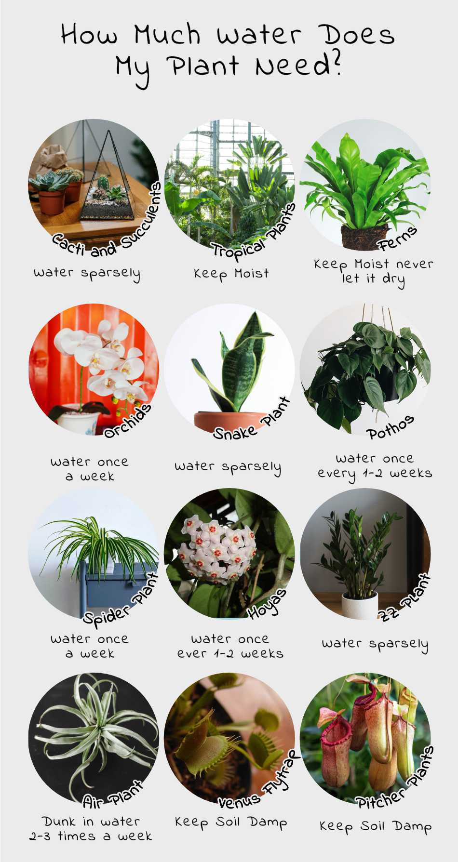
This project not only improves plant care but also helps in water conservation and reduces manual effort. It reflects my technical knowledge in Arduino programming, sensor interfacing, relay control, and embedded system design while addressing a practical environmental issue.


Sufficient watering plants are healthy


Problem Statement
Plants require proper and timely watering for healthy growth. However, manual watering methods often result in:
• Overwatering, which damages plant roots
• Underwatering, which leads to plant drying
• Wastage of water
• Lack of monitoring during busy schedules
• No real-time status indication of plant condition
Therefore, there is a need for an automated and smart solution that can monitor soil moisture levels and provide controlled watering with status indication.

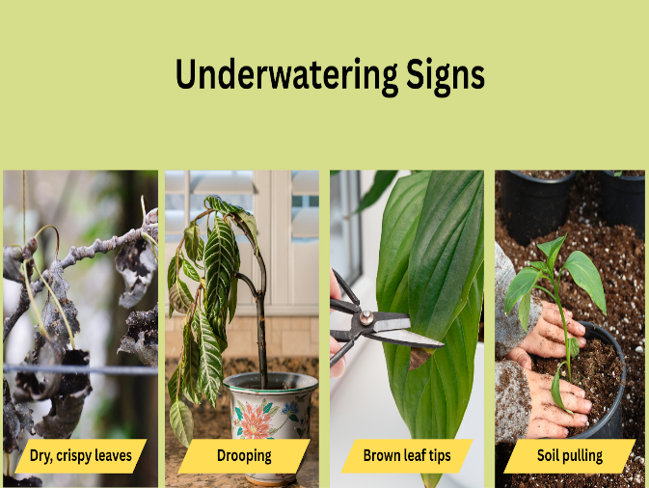

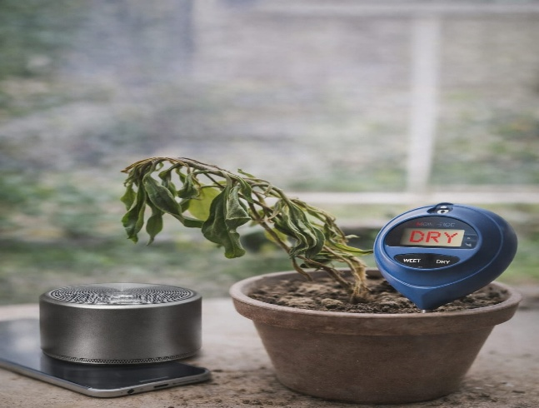
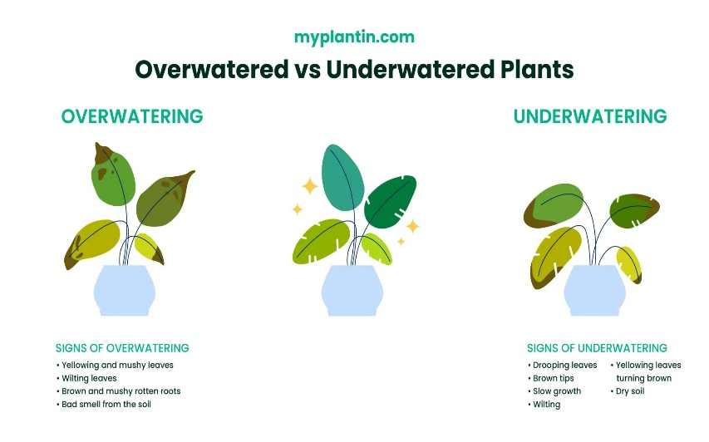
Under and Over Water Causes
Overwatering
Lack of Monitoring
Underwatering Signs

Objective
To design and develop an automatic plant watering system using Arduino.
To monitor soil moisture, temperature, and humidity using sensors.
To prevent wastage of water by supplying water only when the soil is dry.
To alert the user using an external magnetic speaker when moisture level is low.
To reduce manual effort and save water efficiently.
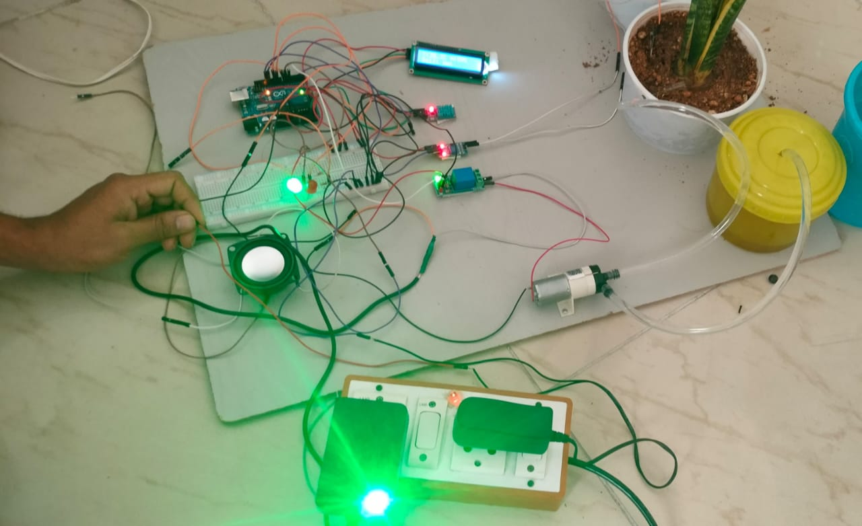
To improve plant growth by maintaining proper moisture levels automatically.

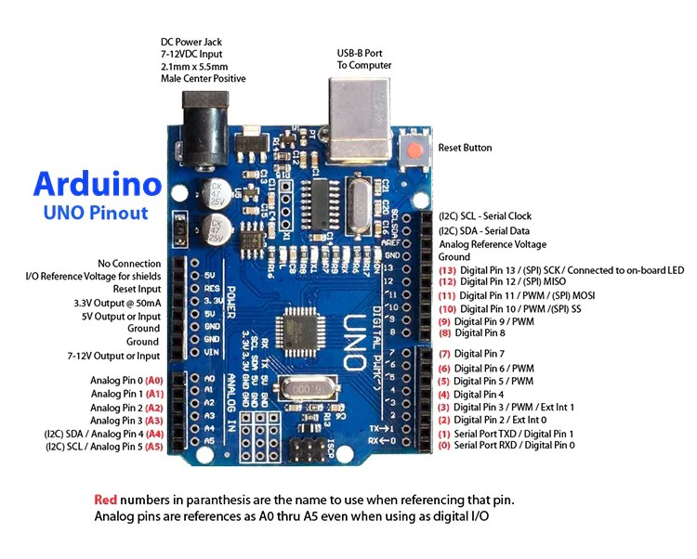
Smart Plant Watering with Alert System
🔹 Technology Used
1️⃣ Arduino Uno
Type: ATmega328P Microcontroller Board
- Purpose: Main controller of the system
- Reads soil moisture level
- Reads temperature & humidity from DHT11
- Controls relay for pump operation
- Sends commands to DF Player
- Displays data on I2C display
Arduino Uno
Pins Used:
D2 – Soil moisture sensor
D3 – DHT11 sensor
D8 – Relay control
D10, D11 – DF Player (Software Serial)
A4 (SDA), A5 (SCL) – I2C Display
2️⃣ I2C Parallel Display (16x2 / 20x4 LCD with I2C Module)
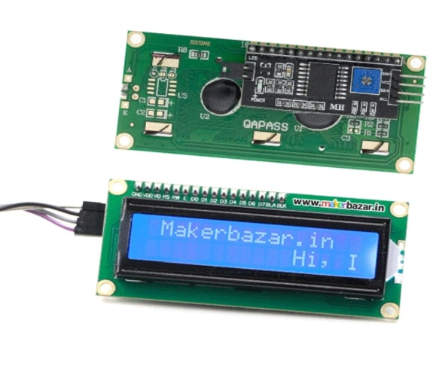
Pins:
SDA – A4
SCL – A5
VCC – 5V
GND – GND
Purpose:
Displays soil moisture status (Dry/Wet)
I2C Parallel Display
Shows Temperature (°C) and Humidity (%)
Shows Pump ON/OFF status
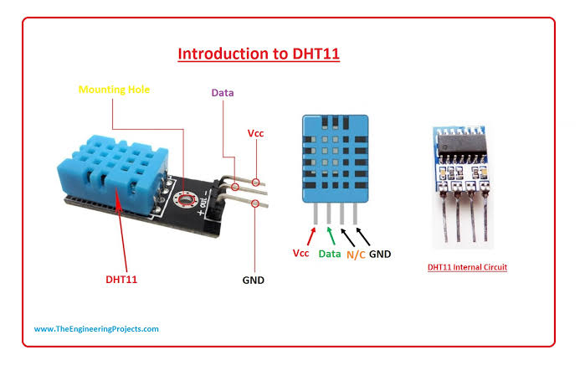
Displays alert messages
3️⃣ DHT11 Sensor
Pin Used: D3
Purpose:
Measures temperature
Measures humidity
DHT11 Sensor
Provides environmental monitoring
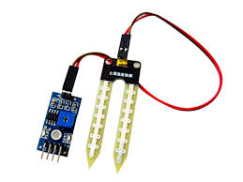
Helps prevent overheating conditions
4️⃣ Soil Moisture Sensor
Pin Used: D2 (Digital) or A0 (Analog)

Purpose:
Detects dryness of soil
Soil Moisture Sensor
Sends signal to Arduino
Automatically triggers pump when soil is dry

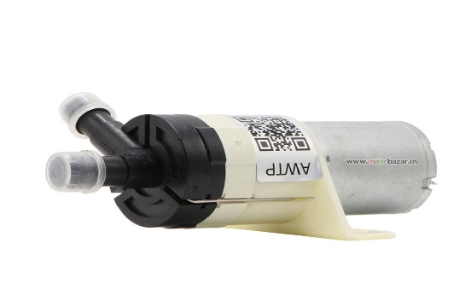
5️⃣ Self-Priming Water Pump
Voltage: 12V DC
Purpose:
Pumps water to plant automatically
Operates only when soil moisture is low
Self-Priming Water Pump
Stops when sufficient moisture is reached
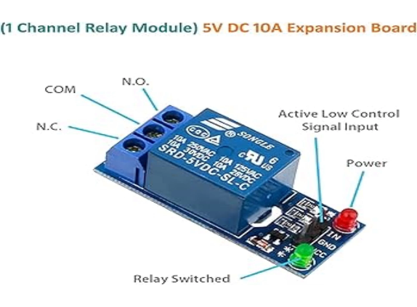
6️⃣ Relay Module (Pump Control)
Pin Used: D8
Connection:
IN – D8
VCC – 5V
GND – GND
Logic:
Relay Module
HIGH → Pump ON
LOW → Pump OFF
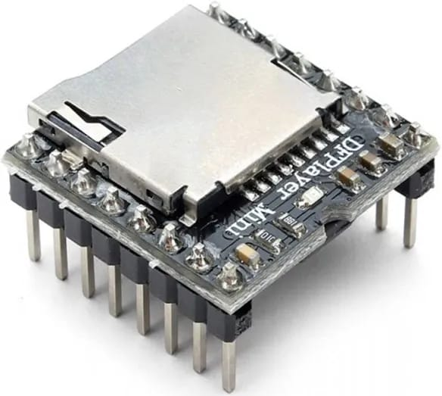
Purpose:
Safely controls high-voltage pump using Arduino
7️⃣ DF Player Mini
Pins:
RX – Arduino D10
TX – Arduino D11
DF Player
SPK1 & SPK2 – External Magnetic Speaker
Purpose:
Plays voice alerts
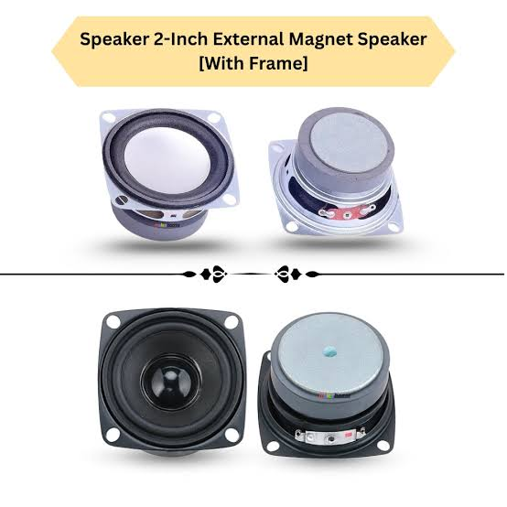
Audio files stored in microSD card
Audio Files:
001.mp3 → “Soil is Dry – Watering Started”
002.mp3 → “Soil Moisture Normal – Pump Stopped”
8️⃣ External Magnetic Speaker
Connection: SPK1 and SPK2 of DF Player
Magnetic Speaker
Purpose:
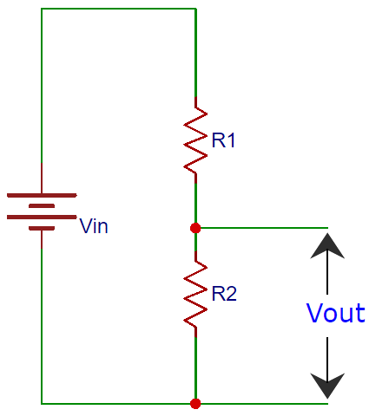
Produces loud voice alerts
Replaces buzzer/alarm
Provides clear monitoring sound
9️⃣ Voltage Divider Circuit (For DF Player RX Protection)
Components: R1=1kΩ and 1kΩ resistors
Purpose:
Reduces Arduino 5V TX signal to ~3.3V
Protects DF Player RX pin
Voltage Divider circuit for RX Pin
Ensures safe communication
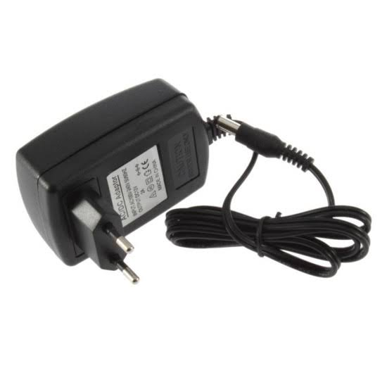
🔟 Power Supply

12V Adapter: For self-priming pump
5V Supply (USB/Regulated): For Arduino & Sensors
Purpose:
Provides stable power
Separates motor supply from controller supply
Prevents voltage fluctuations
Power Supply Adapter

ARDUINO CODING THROUGH ARDUINO IDE
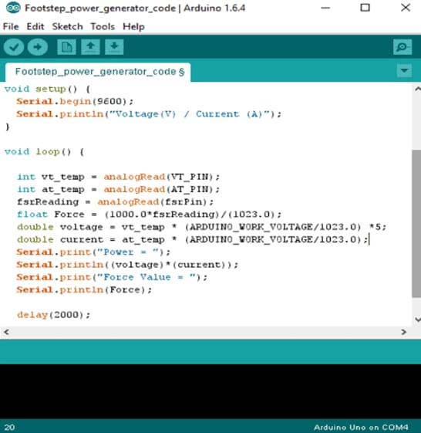
Select Board and Port: In the IDE, go to Tools > Board and select your Arduino model. Then go to Tools > Port and select the correct COM port.
Test Installation: Open File > Examples > Basics > Blink, upload the sketch, and see if the onboard LED blinks.
ARDUINO CODE
digitalWrite(LED_WET, LOW);
dht.begin();
if(!myDFPlayer.begin(mySerial)){
serial.println(“DFPlayer Mini not found!” );
while(true);
}
myDFplayer.volume(25)
}
void loop() {
float humidity = dht.readHumidity();
float temperature = dht.readTemperature();
int moistureValue = analogRead(SOIL_SENSOR);
// Convert soil moisture to percentage
int moisturePercent = map(moistureValue, 1023, 0, 0, 100); // Dry = 1023, Wet = 0
// Check if DHT reading is valid
if (isnan(humidity) || isnan(temperature))
{
Serial.println("Failed to read from DHT11");
lcd.clear(); lcd.setCursor(0, 0);
lcd.print("Sensor Error");
delay(2000);
return;
}
// Print to Serial Monitor
Serial.print("Humidity: ");
Serial.print(humidity);
Serial.print("%, Temp:
Serial.print("%, Temp: ");
Serial.print(temperature);
Serial.print("C, Soil: ");

#include <Wire.h>
#include <LiquidCrystal_I2C.h>
#include <DHT.h>
#include<softwareSerial.h>
#include<DFRobotDFPlayerMini.h>
// LCD I2C address
LiquidCrystal_I2C lcd(0x27, 16, 2);
// DHT11 Sensor Settings
#define DHTPIN 2
#define DHTTYPE DHT11
DHT dht(DHTPIN, DHTTYPE);
// Pins
#define RELAY_PIN 8
#define LED_DRY 10
#define LED_WET 11
#define SOIL_SENSOR A0
SoftwareSerial myserial(10,11);
DFRobotDFPlayerMini myDFPlayer;
void setup() {
Serial.begin(9600);
dht.begin();
lcd.begin(16, 2);
lcd.backlight();
pinMode(RELAY_PIN, OUTPUT);
pinMode(LED_DRY, OUTPUT);
pinMode(LED_WET, OUTPUT);
pinMode(SOIL_SENSOR, INPUT);
// Initial states

lcd.clear();
lcd.setCursor(0, 0);
lcd.print("T:");
lcd.print(temperature);
lcd.print((char)223);
lcd.print("C H:");
lcd.print(humidity);
lcd.print("%");
lcd.setCursor(0, 1);
lcd.print("Moisture:");
lcd.print(moisturePercent);
lcd.print("%");
// Relay Control Based on Humidity
if (humidity < 20 || moisturePercent < 30)
{
digitalWrite(RELAY_PIN, HIGH); // Turn ON motor
digitalWrite(LED_DRY, HIGH); // DRY condition
digitalWrite(LED_WET, LOW);
myDFPlayer.play(1)
delay(1000);
myDFPlayer.play(2)
} else if (humidity > 85 || moisturePercent > 70) {
digitalWrite(RELAY_PIN, LOW); // Turn OFF motor
digitalWrite(LED_DRY, LOW);
digitalWrite(LED_WET, HIGH); // WET condition
} else { // Mid zone: turn everything off
digitalWrite(RELAY_PIN, LOW);
digitalWrite(LED_DRY, LOW);
digitalWrite(LED_WET, LOW); }
delay(2000); }

Libraries used
1. Wire.h – For I2C communication (used by LCD).
2. LiquidCrystal_I2C.h – For controlling the I2C-based LCD display.
3. DHT.h – For reading temperature and humidity from the DHT11 sensor.
4. SoftwareSerial.h – For creating a secondary serial port (used by DFPlayer Mini).
5. DFRobotDFPlayerMini.h – For controlling the MP3 player module (DFPlayer Mini).
CIRCUIT DIAGRAM
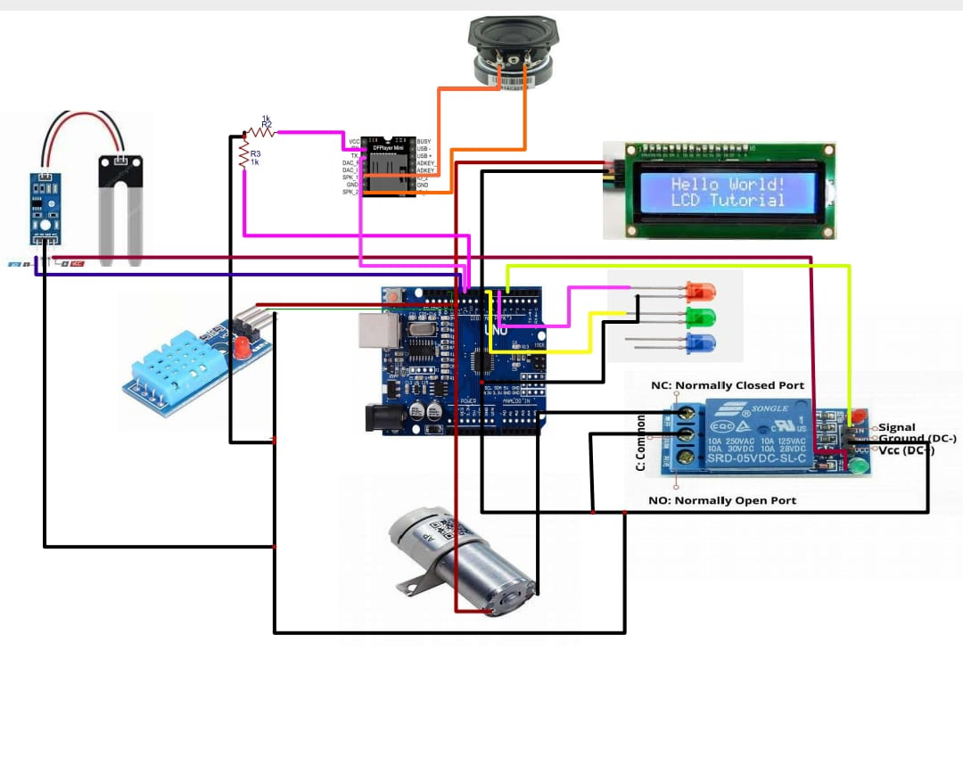
PRACTICAL IMPLEMENTATION

Methodology
The Smart Plant Watering System is designed to monitor soil moisture levels using a soil moisture sensor placed near the plant roots. The sensor continuously measures the moisture content in the soil and sends the readings to a microcontroller (Arduino/ESP32).
When the soil moisture level falls below a predefined threshold, the system activates a buzzer to provide an audio alert indicating that the plant needs watering. Once water is supplied and the soil reaches the required moisture level, the alert automatically stops.
An optional LCD/OLED display can be used to show real-time moisture readings. The system operates on low power and is suitable for home gardens, indoor plants, and small agricultural setups.
Expected Outcome
Alerts the user when the plant needs water through an audio signal.
Prevents overwatering and underwatering of plants.
Promotes healthy plant growth.
Saves water by ensuring watering only when required.
Suitable for home, school, and small garden applications.
Simple, cost-effective, and user-friendly system.
Skills Gained
Improved knowledge in circuit design and sensor interfacing.
Programming skills in C/C++ using Arduino IDE.
Understanding of soil moisture sensing technology.
Experience in testing, calibration, and troubleshooting.
Practical knowledge in embedded systems and real-time monitoring.
Conclusion
The Smart Plant Watering System with Audio Alert demonstrates an effective and practical solution for plant care using embedded system technology. By monitoring soil moisture and providing timely audio alerts, the system ensures proper watering and promotes plant health.
This project strengthened my understanding of microcontrollers, sensor integration, and real-time embedded applications. It also highlights the importance of sustainable water usage and smart automation in daily life.

